

**Tribhuvan University**

Faculty of Humanities and Social Sciences

**News Portal System**

**A PROJECT REPORT**

**Submitted To:**

**Department of Computer Application**

**Ratna Rajyalaxmi Campus**

***In partial fulfillment of the requirement for the Bachelor in Computer Application***

**Submitted By:**

KHEMRAJ NEUPANE (6-2-40-18-2021)

GANIT LAL RAJBANSHI (6-2-40-16-2021)

**Under the Supervision of**

**Ananda K.C**



**Tribhuvan University**

Faculty of Humanities and Social Science

Ratan Rajya Laxmi Campus

# SUPERVISOR’S RECOMMENDATION

I hereby recommend that this project prepared under my supervision by KHEM RAJ NEUPANE and GANIT LAL RAJBANSHI entitled “Online News Portal System” in partial fulfillment of the requirements for the degree of Bachelor of Computer Application is recommended for the final evaluation.

________________________

Ananda K.C

SUPERVISOR

Department of Computer Application

Pradarshani Marg, Kathmandu



Tribhuvan University

Faculty of Humanities and Social Sciences

Ratan Rajya Laxmi Campus

# LETTER OF APPROVAL

This is to certify that the project prepared by KHEMRAJ NEUPANE And GANIT LAL RAJBASHI entitled “Online News Portal System”. In partial fulfillment of the requirements for the degree of Bachelor in Computer Application has been evaluated in our opinion it id satisfactory in the scope and quality as a project for the required degree.

|  |  |
| --- | --- |
| **SIGNATURE of Supervisor**  -------------------------------------  Ananda K.C  Lecturer, Project Supervisor  Ranta Rajyalaxmi Campus | **SIGNATURE of HOD/Coordinator**  --------------------------------------------  Mr. Bhupendra Ram Luhar  Coordinator  Department of BCA  Ratna Rajyalaxmi Campus |
| **SIGNATURE of Internal Examiner**  ---------------------------------------- | **SIGNATURE of External Examiner**  **---------------------------------** |

# **ACKNOWLEDGEMENT**

The project presented in the report was conducted and showcased at Ratna Rajya Laxmi Campus. Faculty of Humanities and Social Sciences. Tribhuvan University of Technology, as part of the Bachelor of Arts in Computer Application program. This project server as a testament not only to technical proficiency but also to team work and performance amidst various Challenges. The successful completion of this journey owes much to the invaluable assistance provided by expert.

Additionally, we extend our gratitude to the lectures of the Department of Computer Application for their generosity in sharing their expertise, which greatly contributed to the development of this project. We are also thankful to our friends for their unwavering support and to the respondents whose feedback helped enhance our project work.

we will be ever grateful to our supervisor **Mr. Ananda K.C**, lecturer without whose guidance, this project would not have become successful.

We are also grateful to our department coordinator **Mr. Bhupendra Ram Luhar**.

Finally, our greatest appreciation and love goes to our families, friends and mentors and for sure this would not have happened without their unconditional love, care and support.

# **ABSTRACT**

The Propose of “Online News Portal System” to automate the existing manual system by the helps of computerized equipments and full-fledged computer software, fulfilling their requirements, so that their valuable data/information can be stored for a longer period with easy accessing and manipulation of the same. The required software and hardware are easily available and easy to work with.

Online News Portal as described above can lead to error free, secure reliable and fast management system. It can assist the user to concentrate on their other activities rather to concentrate on the record keeping. The organization can maintain computerized records without redundant entries.

The aim is to automate its existing manual system by the help of computerized equipments and full-fledge computer software, fulfilling their requirements, so that their valuable data\information can be stored for a longer period with easy accessing and manipulation of the same.

**TABLE OF CONTENTS**

SUPERVISOR’S RECOMMENDATION ii

LETTER OF APPROVAL iii

**ACKNOWLEDGEMENT** iv

**ABSTRACT** v

LIST OF FIGURES viii

LIST OF TABLES ix

LIST OF CONTENT x

**CHAPTER 1: INTRODUCTION** 1

**1.1. Background** 1

**1.2. Problem Statement** 1

**1.3. Objectives** 2

**1.4. Scope and Limitation** 2

**1.5 Report Organization** 2

**CHAPTER 2: BACKGROUND STUDY AND LITERATURE REVIEW** 4

**2.1. Background Study** 4

**2.2. Literature Review** 4

**CHAPTER 3: SYSTEM ANALYSIS AND DESIGN** 5

**3.1. System Analysis** 5

**I.** **Functional Requirement (Illustrated using use case Diagram/list)** 5

**II.** **Non-Functional Requirements** 6

**3.1.3. Data Modeling (ER-Diagram)** 7

**3.1.4. Process Modeling (DFD)** 7

**3.2. System Design** 7

**3.2.1. Architectural Design** 7

**3.2.2. Database Schema Design** 7

**3.2.3. Interface Design (UI Interface / Interface Structure Diagrams)** 7

**3.2.4. Physical DFD** 7

**3.2.4. Database Design** 7

**CHAPTER 4: Implementation and Testing** 9

**4.1. Implementation** 9

**4.1.1. Tools Used (Case Tools, Programming Languages, Database Platforms)** 9

**4.1.2. Implementation Details of Modules (Description of Procedures/Function)** 9

**4.2. Testing** 9

**4.2.1. Test Cases for Unit Testing** 10

**4.2.1. Test Cases for system Testing** 11

**5. Conclusion and Future Recommendations** 12

**5.1. Lesson Learnt / Outcome** 12

**5.2. Conclusion** 12

**5.3. Future Recommendations** 12

# LIST OF FIGURES

Figure 1: Use Case Diagram of online portal System. 5

Figure 2: Architectural Design 7

Figure 3: Database Schema Design 8

Figure 4: Add New Reporter 9

Figure 5: Post Table 9

Figure 6: Comment Table 9

# LIST OF TABLES

Table 1: Test case 1 Register 11

Table 2: Test case 2 Register Unsuccessful 11

Table 3: Test case 3 login 12

Table 4: Test case 4 system Test 12

# LIST OF CONTENT

# **CHAPTER 1: INTRODUCTION**

## **1.1. Background**

The purpose of the project is to develop an “Online News Portal System” and provides news for all viewers. Online news portal allows customers to read up to data news related to many fields like Entertainment, National and International events, Sports, Politics, Education etc., without any payment or login. New News can be added or posted only by the admin and only admin have the authorization to other to update add or delete news.

The online news portal has been developed to override the problems prevailing in the practicing manual system. The main purpose of the project is intended to develop a portal for management of Web based news. No formal knowledge id needed to use the portal. The portal provides a suitable and easy display for which large population around the world can learn or will have the knowledge about the world. Online news portal allows customers to read up to date news related to many fields like Entertainment, National and International events, sports, politics, education etc. without any payment or login. New News can be added or posted only by the admin and only admin have authorization to update or delete any news. It will be a popular source of information for people who want to stay informed about current events and news from around the world. The portal provides a suitable and easy display for larger population around the word can learn or will have the knowledge about the world. No format knowledge is needed to use this portal. Admin has the right to give authority to other to update add or delete news.

Now-a-day we live in age Information Communication and Technology (ICT). Form morning to night, we need help of the technology. We can’t think a single moment without technology. Most of the words depends on web application. We have developed our project so that we can aware the people. For this reason, anytime, anywhere, anyone can access a website by internet at low cost and we can find our expectable and most update information from website. At present information is one the most valuable resources of the current world. We have developed our project so that we can aware the people.

The project is developed by using PHP and MYSQL on the back end. For the front end, we use HTML, CSS and JS.

## **1.2. Problem Statement**

The problem statement for developing an online news portal system.

* Decline of Traditional Media
* Accessibility and Convenience
* Fake News and Misinformation

## **1.3. Objectives**

The main Objective of a good Online News Portal is mentioned as such.

* The Objective of this project is to provide the daily news.
* To add any new information without any complexity.
* Anytime, anywhere, anyone can know about the news or information by internet at low cost.
* Dynamically provides facility.
* To find the perception of reader about local news.
* To develop a user-friendly online news portal system.
* To provide real-time news updates to users.
* Publish News about local region town/city, state, national, international and sports.
* Provides all type of news to the user and they could real anytime.
* Developing the comments reply and its feedback system.

## **1.4. Scope and Limitation**

**Scope:**

The future scope of our project is valuable. In this time we developed our project. it was very difficult to complete project within this duration time. In future if we get chance we will develop this website for large volume. As other future developments, the following can be done. As for other future developments, the following can be done.

* Be easy to understand by the user and operator.
* Be easy to operate.
* Have a good user interface.
* It satisfy the user requirement.
* Admin can add a new Reporter.

**Limitation:** There are some limitations for the current system to which solutions can be provided as a future development.

* The user reply system has not developed.
* Language changing system has not developed.
* The user dark mode system has not developed.
* The User contact system has not developed.
* Breaking News system has not developed.
* Advertising system has not developed.

## **1.5 Report Organization**

In this project we have develop an “Online News Portal website. It is dynamic system. It can be maintain and changed easily because it is based on database. It’s contain web page that are generated in real-time. These pages include Web Scripting code such as PHP. It fully secured from unauthorized access. In a world it can say that our “Online News Portal” website is a completely dynamic website.

To create the system, we have worked on all possible types of basics code used for principle of design based on mainly on PHP, CSS, JS and HTML, Here we have used incremental model to create the system. We have collected all kinds of information related to this system from the customer.

The project background model specially designed on the basic of certain web programming language like PHP, MYSQL, CSS etc. In following section here, we are going to give a brief description about this language in this project.

# **CHAPTER 2: BACKGROUND STUDY AND LITERATURE REVIEW**

## **2.1. Background Study**

Online news Portal System

## **2.2. Literature Review**

A lot of project work has carried on Online News Portal System. At the present time, Online News Portal websites are available. But most of this website is static and traditional. There is no feature that can make people awareness. This is why we have done this project. Our project has many features that can aware the people. By using this website one can get more and more information that helps the people in their daily life.

# **CHAPTER 3: SYSTEM ANALYSIS AND DESIGN**

## **3.1. System Analysis**

System analysis is a process of gathering and interpreting facts, diagnosing problems and the information about the Online News Portal to recommend improvements on the system. It is a problem solving activity that requires intensive communication between the system user and system development. System analysis or study is an important phase of any system development process. The system is studied to the minutest detail and analyzed. The system analyst plays the role of the interrogator and dwells deep into the working of the present system. System analysis is concerned with becoming aware of the problem, identifying the relevant and decisional variables, analyzing and synthesizing the various factors and determining an optimal or at least a satisfactory solution or program of action. The output from the organizations are traced to the various processes.

This system is called the existing system. Now the existing system is subjected to close study and problem areas are identified. The solutions are given as proposals. The proposal is then weighed with the existing system analytically and the best one is selected. The proposal is presented to the user for an endorsement by the user. This is loop that ends as soon as the user is satisfied with proposal. Preliminary study is the process of gathering and interpreting facts, using the information for further studies on the system. It does various feasibility studies. In these studies a rough figure of the system activities can be obtained, from which the decision about the strategies to be followed for effective system study and analysis can be taken.

**3.1.1. Requirement Analysis**

1. Requirement analysis is a softer engineering task that bridges the gap between the system level software allocation and software design.
2. It provides the software designer with are presentation of information and function that can be translated to data, architectural and procedural design.
3. It enables the system engineering to specify function and performance indicate software interface with other system elements.

### **Functional Requirement (Illustrated using use case Diagram/list)**

Function requirements define the fundamental actions that system must perform. The functional requirements for the system are divided into various categories as admin, editors and user further details, refer to the use cases.

The Use case Diagram of the system (Online News Portal System) is given below:

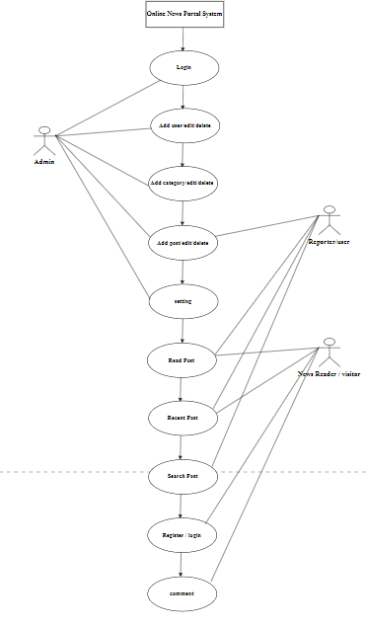

Figure : Use Case Diagram of online portal System.

In this above Use case diagram, there are two modules where each of the modules have their specific function.

### **Non-Functional Requirements**

1. Portability: Our system platform independent system so it can run in any browser.
2. Security: There is a high security in keeping the information of user and transaction of money.
3. Backup: Incase of system failure there is database which will store all the information about all the client.
4. User friendly: Our system is user friendly, it can be easily use and understand by user.

**3.1.2. Feasibility Analysis**

A feasibility study aims to objectively and rationally uncover the strengths and weaknesses of an existing business or proposed venture, opportunities and threats present in the natural environment, the resources required to carry through, and ultimately the prospects for success.

1. **Technical**

The system can be implemented in various technologies which are presently available as well as in all technologies which will be implemented in future. In this feasibility, technical factor like hardware and software are studied and decided that the system can be develop and implemented using existing technology.

* Hardware Requirement

Processor:

Disk space:

Ram:

* Software Requirement

Operating System:

Web Browser:

Google Chrome XAMPP, MYSQL

* Programming Language: HTML, CSS, JS, PHP

1. **Operational**

No doubt the proposed system is fully GUI based that is very user friendly and all inputs to be taken all self-explanatory even to a layman. Beside a proper training has been conducted to let know the essence of the system to the users so that they feel comfortable with new system as far our study is concerned the client are comfortable and happy as the system has cut down their loads and doing.

1. **Economic**

This aims to determine the positive economic benefits to the organization that the proposed system will provide. The system is economically feasible to be implemented because it is web-based application.

* The system is cost effective
* The system benefits outweigh costs, then the decision is made to design and implement the system.

### **3.1.3. Data Modeling (ER-Diagram)**

### **3.1.4. Process Modeling (DFD)**

### **3.2. System Design**

System design is the most creative and challenging. The System Design Document describe the system requirements, Operating, system and subsystem architecture, files and database design, input formats, output layouts, human-machine interface, detailed design, processing logic, and external interface.

### **3.2.1. Architectural Design**

Figure :Architectural Desig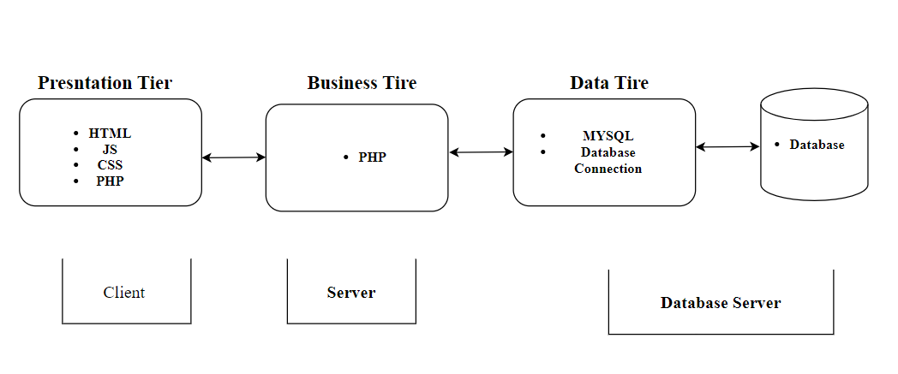n

Architectural Design is a rather creative process. This process entails may steps that intertwine creativity and technical skills, beginning with analyzing the basic needs of the project or client. Then an architectural designer can move on to developing plans for the structure or components of a structure. Finally, the plans are given to other professionals who transform the designer’s vision into a fully function reality. During the structure’s physical construction meets that aesthetic and function plans of the project.

In the proposed system architectural, the presentation tier utilizes HTML CSS and Js form creating website and system elements to present information to user in an organized and visually appealing manner. php server as the primary language for both the business tier and the presentation tier allowing for dynamic content generation and server-side processing.

### **3.2.2. Database Schema Design**

Figure : Database Schema Design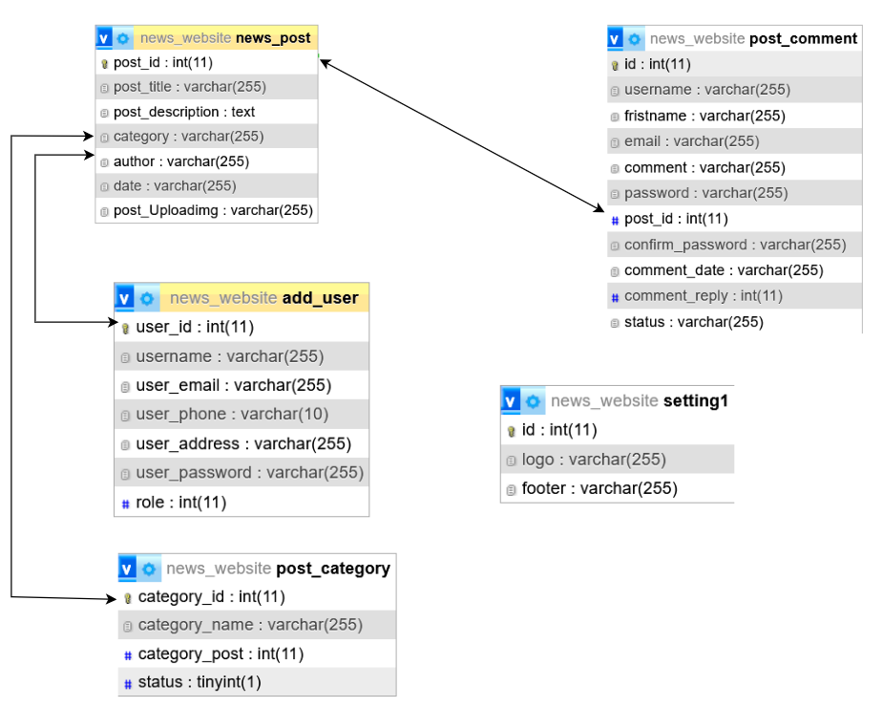

### **3.2.3. Interface Design (UI Interface / Interface Structure Diagrams)**

The user interface (UI) is the point of human-computer interaction and communication in a device. This can include display screens, keyboards, a Mouse and the appearance of a desktop. It also they way through which a user interacts with an application or a website. The various type of user interfaces include: Graphical user interface (GUI), Command Line interface (CLI), Menu-driver user interface, Touch user interface, Voice user interface (VUL), form-based user interface, natural language user interface.

The UI is often talked about in conjunction with user experience (UI), which may include the aesthetic appearance of the device, response time and the content that is presented to the user within the context of the user interface. Both terms fall under the concept of human-computer interaction (HCI), which is the field of study focusing on the creation of computer technology and the interaction between human and all forms of IT design. Specifically, HCI studies areas such as UCD, UI design and UX design.

### **3.2.4. Physical DFD**

0 Level DFD: This level of DFD shows that what input is coming and what processing happens and what are the output results,

### **3.2.4. Database Table**

News Reporter Add / user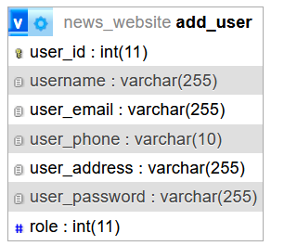

Figure Add New Reporter

Post Table

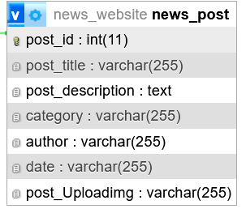

Figure : Post Table

Post Category

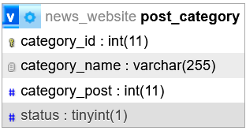

Figure : Comment Table

# **CHAPTER 4: Implementation and Testing**

### **4.1. Implementation**

Detailed Design of Implementation: This phase of system development life cycle refines hardware and software spedflcations, establishes programming plans, trains user and implements extensive testing procedures, to evaluate design and operating specifications and/or provide the basis for further modification.

Technical Design: This activity builds upon specification produced during new system design, adding detailed technical specifications and documentation.

Test Specifications and Planning: This activity prepares detailed test spedflcations for individual modules and programs, and for the system as a whole.

Programming and Testing: This activity encompasses actual development, writing and testing of program units or modules.

### **4.1.1. Tools Used (Case Tools, Programming Languages, Database Platforms)**

This project is developed using the tools, which are most suited for development of the PSTU web-based system. These tools are as follows:

* HTML (For the Front end)
* CSS (Cascading Style for all page)
* JAVASCRIPT
* PHP (For Back end Programming)
* MYSQL (For database Storage as Backend)

### **4.1.2. Implementation Details of Modules (Description of Procedures/Function)**

### **4.2. Testing**

The testing section is accomplished to validate the News portal System. The News Portal System is examined to test if the final system can work in keeping with what we have been waiting for and is free from any progamming and logical errors. It additionally makes sure whether or not all of the system and requirements are met or not.

### **4.2.1. Test Cases for Unit Testing**

Unit testing is a software program development method in which the smallest testable components of an application, know as units, are individually and independently scrutinized for correct operation. Below are the numerous tables for distinctive test case.

Table 1: Test case 1 Register

|  |  |  |  |  |
| --- | --- | --- | --- | --- |
| **S.N** | **Test Case** | **Input** | **Expected Outcome** | **outcome** |
| 1 | Navigate to Register pages | Path: http/localhost/news/pages/  register.php | Register in page should open | As expected i.e. Member is navigated to register in page of system |
| 2 | Provide own details | Username: Full name:  Email: Password: Confirm Password: | Credential an can be entered | As expected |
| 3 | Click register Button | clicked | User should register | As Expected |
| **Post-condition: Register successful** | | | | |

Table 2: Test case 2 Register Unsuccessful

|  |  |  |  |  |
| --- | --- | --- | --- | --- |
| **S.N** | **Test Case** | **Input** | **Expected Outcome** | **outcome** |
| 1 | Whenever the Name field contains a number or a symbol | eg: Unique1  unique@nep | Display error message. | An expected error message is displayed |
| 2 | If the name contains more than 20 alphabets | eg: example12n | Display error message | An expected error message is displayed. |
| 3 | if an invalid email address is entered | eg: Exam@1eGamil.com | Display error message | An expected error message is displayed |
| 4 | If the email address entered is already registered |  | Display error message | An expected error message is display |
| 5 | If the password length is less or more than 10 characters | eg: admin@123 | Display error message Output: | An expected error message is display |
| 6 | If the password and confirm password do not match |  | Display error message. | An expected error message is displayed |
| **Post-Condition: Register failed** | | | | |
|  | | | | |

Table 3: Test case 3 login

|  |  |  |  |  |
| --- | --- | --- | --- | --- |
| Pre-conditions: The member has a valid user or email and password | | | | |
| Dependencies : register moudel | | | | |
| **S.N** | **Test Case** | **Input** | **Expected outcome** | **outcome** |
|  |  |  |  |  |
|  |  |  |  |  |

### **4.2.1. Test Cases for system Testing**

System Testing is a from of software testing that is executed on a complete integrated system to assess the compliance of the system with the corresponding requirements.

Table 4: Test case 4 system Test

# **5. Conclusion and Future Recommendations**

## **5.1. Lesson Learnt / Outcome**

## **5.2. Conclusion**

In our project work, an attempt has been made to develop a News or information based website. We develop this project that helps the people and make them aware so that they can know any news. To establish this website we use various methodologies. To develop this project we have faced many problem but we hardly tried to develop this project. Our supervisor helps by giving his valuable opinion, decision and time.

## **5.3. Future Recommendations**

As the Project comes up with some limitation which can be improved in future and further more advancement can also be done. The different features that can be added are as follows:

* Videos of different news can be provided related to various fields like Entertainment, International, National, Sports, Business etc.
* Live support should be enabled.
* More fields can be added.